Blurred images

Using Java, I managed to get the program to open a black canvas and start placing blobs of colours that have been randomly selected form a photo to make a blurred photo of the origin

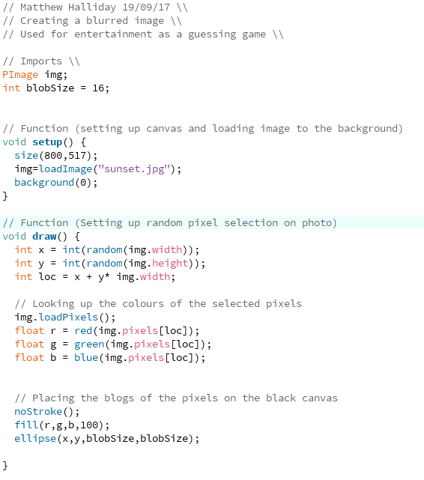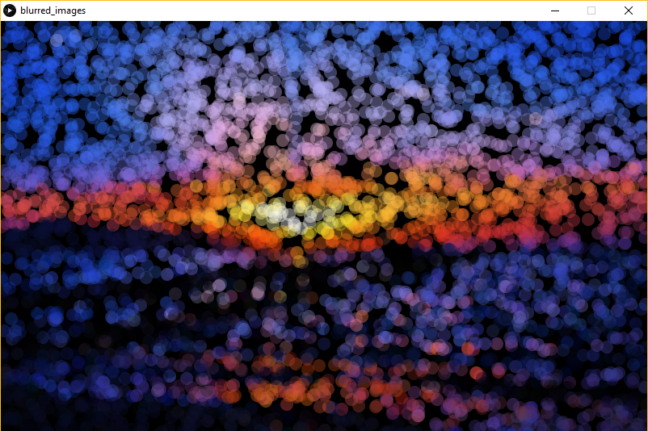

Here is an image of a sunrise that has been set as the background transforming into a sunset 